 | 26.12 Editors - Properties Editor - Physics Properties Tab
Table of content
Physics 1
Physics types 2
Force Field 2
Collision 2
Cloth 2
Dynamic Paint 2
Soft Body 2
Fluid 2
Rigid Body 2
Rigid Body Constraint 3

Physics

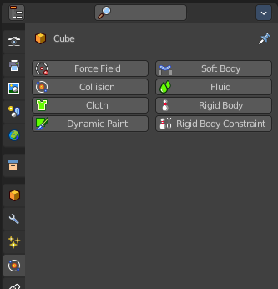
Gravity or collisions are real time physical effects. In the Physics tab you will find some methods to simulate such physical effects to use them in your images or movies. They allow objects to interact with each other. Like collisions. Or that wind forces bends some plant meshes. And much more.

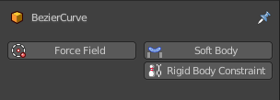
Not every object has a physics tab. And not all physics are available at the object types that has it available. A Bezier curve object for example has just Force Field, Soft Body and Rigid Body Constraints available.

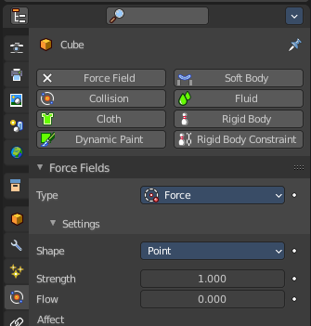
By clicking at one of the buttons you will enable the physics type. And its settings will appear.
Active buttons will have an X at the front. By clicking at it you can remove the physics effect.

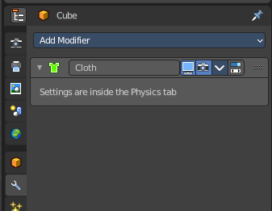
Some Physics types will add a modifier to the modifier stack. Cloth for example.

Physics types

You can add up to eight different types of physics. There can be more than one physics type at the object.

Force Field
As the name says, this physics type adds forces. Wind for example. And the forces can influence other physic types like particles, soft bodies, cloth and rigid bodies.

Collision
Collision physics is meant for collisions. Particles, Soft Bodies and Cloth objects may collide with mesh objects. Boids try to avoid Collision objects.

Cloth
Cloth is a physics effect that tries to simulate the motion and behavior of fabrics.

Dynamic Paint
Dynamic paint is a modifier and physics system that can turn objects into paint canvases and brushes. With Dynamic Paint you can create vertex colors, image sequences or displacement. This makes many effects possible like, for example footsteps in the snow, raindrops that make the ground wet, paint that sticks to walls, or objects that gradually freeze.

Soft Body
Soft body simulation is used for simulating soft deformable objects.

Fluid
Fluid physics is used to simulate liquids.

Rigid Body
Rigid bodies simulates the motion of solid objects. They can receive forces, gravity or acceleration for example. And allows collision without to deform them. Just mesh objects can have rigid bodies.

Rigid Body Constraint
Rigid body constraint is used to connect two rigid bodies. This can be the position, or the rotation or scale.

